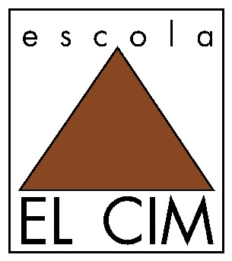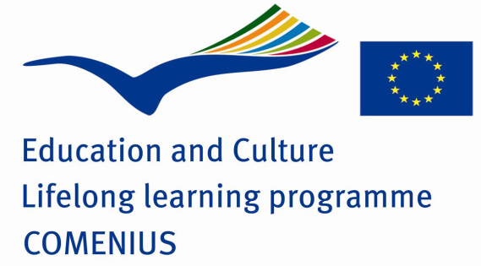

METHODOLOGIES FOR TEACHING/LEARNING INTERCULTURAL COMPETENCE
El CIM School, with 700 students, is a semi-private school managed by a cooperative society of workers, with an antiquity of more than 40 years, which is defined as a Catalan school, plural and open to everybody.
The main target of the school is the integral formation of its pupils, based on significant learning, respect towards people and natural and social surroundings. The school is open to integration inside the educative process, this is the reason why in its classrooms there are students with disabilities, immigrants’ children and immigrants.
The Catalan Curriculum underlines the importance for all pupils to acquire an intercultural communicative competence in accordance with the society in which they are living.
Children should finish Secondary school having the ability to communicate ‘perfectly’ in Catalan, considered to be the language of Catalonia, and also in Spanish. They should also show respect towards linguistic diversity and desire to learn other languages and to learn from all languages and cultures.
The Catalan education system is based on a bilingual immersion system envisaged, when it was implemented, to promote Catalan competence among all students who came from Spanish family backgrounds. It was expected to have linguistic educational and social benefits for the students involved. It led to a language shift for many children who spoke Spanish at home and Catalan at school. Children receive instruction in a Catalan immersion system and have Spanish as a separate subject, in order to guarantee that they will complete their compulsory education being fluent in both languages. This model is based on Cummins’ Linguistic Interdependence Hypothesis (1979) which establishes the existence of a general linguistic competence which can be linked to one language or to another. Cummins’ underlying linguistic competence suggests the inexistence of separate compartments for each language and the existence of an underlying capacity general to all languages (1984).
It could be suggested that the bilingual approach on which the Catalan education system is based is no longer applicable, as an increasing number of schools have many more foreign students than Catalan students. A high percentage of these students no longer have just one home language. Many have two, three or even four home languages.
In terms of our general approach, we are convinced that the need for and the urgency and value of a true education in intercultural competence go beyond the limits of the formal education system. Education in intercultural competence is not an exclusive competence of the education system; it also belongs to parents, families and society in general. Learning about citizenship starts at home, continues at school and conditions a person's development on a community level.
This type of citizenship is not the exclusive consequence of the will of legislators or the state; rather it is the will of all free citizens and free societies. Democratic citizenship is not a by-product of the state, its legislators or politicians; it is the result of the effort of society as a whole. This guidance makes our commitment to public spaces of democratic deliberation as a place for promoting citizenship clear. Instead of presenting a type of citizenship that fits into political spaces, then, we present a type of citizenship made for public spaces. In all democratic citizenship courses, political spaces are necessary, but they are also insufficient.
We want our citizenship education to be active. In line with European Union guidelines, democratic citizenship demands active citizens, and this means that the people who make up a political community must not passively conform to the duties outlined in the laws of their respective countries, but that they must also take shared responsibility for everything that happens in public spaces. Citizenship is active when it appeals for, motivates and promotes the participation of citizens. It is not enough to develop feelings of belonging and to learn about rights; active citizenship generates ways of participation and the learning of responsibilities. Citizenship education cannot exist if there is no teaching of shared responsibility, because rights are accompanied by duties.
Our methodologies have been created to respond to the new ethical, political and cultural challenges that all democratic citizenships must face. Our approach also aims to be universal, but not only because we are concerned with the extension and impact of democratic citizenship. It is important to know that citizenship goes beyond the borders of states, nations and people, and it is also important to know that democratic citizenship is the result of effort, sacrifice, study and memory. Learning about citizenship cannot be reduced to learning about rights; it should be extended to the radical longing for freedom, justice and peace that have always been present in the history of humanity.
Commitment to pluralism does not excuse us from coming up with convincing arguments and a shared search for truth, thus making the type of civic responsibility we propose inclusive, rather than exclusive.

