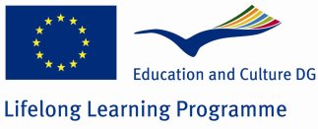

Comenius Project

Preparing for the 21st century: Challenges facing a changing society.

ESCOLA EL CIM.

TERRASSA - CATALONIA

IDEAS FOR COMBATING POVERTY
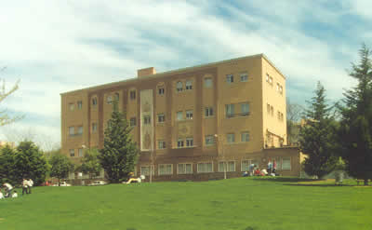

Fundació Busquets

After visiting Fundació Busquets our students have reached the following conclusions:

Poverty is a universal issue and it is increasingly worrying. It affects the whole world and our society. For this reason we should value life and know how lucky we are to have a family, a home, school, values. We have a pretty easy life.
To collaborate actively with organizations like Busquets Foundation that helps people who need it.
Maintain professional and social services offered by organizations like Fundació Busquets: housing for children without families, wardrobe, among others.
We can help alleviate the situation of the poor by making donations, both individual and at institutional level (enterprises, schools, charitable groups…). The most needed products are food, clothing, soaps and cleaning products.
Volunteering is very necessary, especially in the present world, in which people are often motivated by their economic interests. We should encourage voluntary actions in order to improve society and improve ourselves on a personal level.
To raise the awareness in society, and specifically students, about different types of poverty, its distribution, risk groups and especially that poverty also exists in developed countries. It’s also a strategy to combat it.
Promoting personal autonomy by professional training, education and also promoting personal and social abilities of people is important to eradicate it.
It is necessary to console those who need it.
The sponsorship of children is one way to help families who can afford their care for short periods.
Help homeless people to find links to new people, help them recover from the internal injuries of life and get out of this vicious circle.
To organize charitable activities such as plays, concerts, charity raffles, etc.
To eradicate poverty in underdeveloped countries we should stop exploiting people and resources,
It is very important the attitude of society, that takes a look supportive, respectful and dignified treatment to those suffering from this situation. Zoom victim-hood, guilt and contempt for these people.
The collaboration of everyone is essential to eradicate poverty.

You can find more information in this link:
http://www.hijascaridad.org/barcelona/c_hogares/Centros/centro2.htm

