***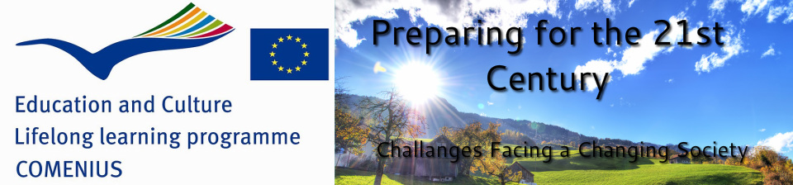***

**BROCHURE**

**E U R O P E A N I D E A S FOR**

**C O M B A T I N G P O V E R T Y**

**COMENIUS PROJECT:**

**PREPARING FOR THE 21ST CENTURY: CHALLENGES FACING A CHANGING SOCIETY**

**ROMANIA**

**Organisation full legal name:**

**Liceul Teoretic “I.L.Caragiale”**

**Type of organisation: General Secondary School**

**City: Moreni**

**METHODS TO COMBAT THE POVERTY**

**1. Education**

The right to education belongs to everyone and in the future the new generation will have the chance to get a normal life and a job, so the risk to become homeless and bankrupt will be zero. The education is the chance of every child to have a good future. With a good and a proper education, a child can get a good job. When the education is given on a higher level, the job will be better, too. You can work at a site for a low wage or in your own office, for a really advantageous salary.

**2. Workplaces**

The unemployed people should have new workplaces which can assure them better lives. The education should prepare the new generations, so they could have a workplace in the future. The government should help the students with the business life of the 21st century to find a job easier.

**3. Food**

The town halls and the local councils have to find methods to obtain food and other things which are necessary for the poor people. Some people can think that easier ways to obtain food are stealing and searching through the garbage. For these people the social system should offer a workplace for a proper wage.

**4. Elaborated plans for the elderly**

For the elderly we need a national plan to give them the opportunity to have a normal life and to live in decent conditions.

**5. Help for disabled persons**

An advanced system should be created for disabled persons who cannot work, so they could have the chance to live a proper life . The disabled persons who cannot work should have a social help in cash. There are specialized persons hired to take care of the persons with disabilities. Also, the persons with mental diseases should have a proper care in special centres.

**6. The animals**

Animals can also be victims of poverty. Here we can talk about dogs, cats and horses. For these animals we can build special centres for healing and adoption. Many animals die in a cruel way just because people ignore them. Stray animals are usually left in the streets by their owners because they have no money to feed them anymore.

**7. Social help**

Poor families with many children are usually victims of the collective poverty. Having many children, the parents are forced to sell objects for money, just to buy some food and water. In these families, both parents should have proper workplaces and the governments should give them help in money or in a temporary house. Poor families with many children should have a proper place to live in, and there should be workplaces for parents, so they could earn money for the family in a good and legal way not by stealing and cheating.

**8. Medical centres**

Many people die because they have uncured diseases and they don’t even have money to buy food or to pay the bills. For these people we should build special centres where they could stay, eat and live better.

**9. Stop globalisation**

Multinational companies start new branches in countries with bad economy for cheap workforce and then they take the profit and invest it in the first branch’s homeland ecconomy. This increases the differences in levels among countries and causes very high prices in countries with larger imports than export, leaving people with not enough income to buy basic stuff required in a household.

**10. Study**

Engage all children to finish their studies. Many high school students leave school for the dole they get afterwards, this leaving both the parents and the kid in a bad situation, the young one doesn’t get or finish his studies and both have to live in poverty due to the lack of ability of the young one to work and to gain enough money to live.

**11. Workplaces**

Fine all the people who crave, many people quit their jobs so they may start doing this. The main reason is the fact that often a craver gets more money then a honestly working man.

**13. Market**

Mentain the universities profiles to what the market requires and disolve the pofiles that do not fit the market. This way there won’t be people with advanced studies that starve and waite for some miracle because no one hires them.

**14. The Religious Education**

Governments should add a class in schools to develop Religious Education the meaning of accepting the belief so the people should form a positive mentality which shall grow the capacity to adapt and survive in bad conditions and quit fleeing the fight with the hardships of.

**15. Jobs for poor people**

Release local projects meant to engage poor population without a stable job to clean the streets, take care of the green areas, collect and sort for recicling waste, harvest some vegetables and herbs.

**16. The legislation**

The legislation must be changed so that people with low income should pay less than anybody else, this changes the grounds on which a business begoes bankrupt.

**17. Projects for new jobs**

Involve places of worship into developing morality and self respect as well as implement projects that are meant to give another chance to the disadvantaged to get new jobs.

**18. Social houses**

Such places may get secondary buildings for poor to sleep and have a meal at no cost, but those places shall only be used by those unable to work and sustain themselves.

**19. Protect the nature**

Teach the population the meaning of not to dispel all nature’s resources and recycle more. In this way we could help ourselves by allowing nature to make just enough for everybody.

**20. Agriculture**

The government must allow poor people to work the lands without paying so there would be less unused terrain and at the same time give people in need a second wind/chance.

**21. Farmers**

Governments should make farms on unused terrain and employ the unemployed persons to work. For countries that were heavily strock by the crisis this could mean a second chance and so that less people would get knocked down in the lower poorness.

**22. Infrastructure**

Infrastructure is one of the key items of a nation that needs to be improved and repaired, indefinitely. Infrastructure, everything from roads to electrical lines, to subways, is what keeps large cities running. Without adequate roads and transportation devices, workers would not be able to get to work, which means they would be fired. With sufficient infrastructure, workers can get to work, and the goods that are created in the workplaces can also get to the store, which means a better economy all around. By speeding everything up, there will be more economic growth, which has inherently led to a significant decrease in poverty. Therefore, nations around the world should spend more money on necessary infrastructure improvements, since those will help impoverished people gain their independence from economic woes.

**23. Technology**

With a general increase in technology, it is more likely that business will be attracted simply because of the growth potential and technological availability. However, Technology also makes the every day person's life easier as well, which can lead to more work time, or even more productivity. Overall, having the government provides incentives for technological growth, works the best, because now both business and consumer are receiving the benefits. A rise in technological innovation and creation has historically led to the rise of a nation and the fall of its poverty.

**24. Education**

The role of education in poverty eradication, in close co-operation with other social sectors, is crucial. No country has succeeded if it has not educated its people. Not only is education important in reducing poverty but it is also a key to wealth creation. The role of education in this process is particularly one of achieving universal primary education and adult literacy. The report made by the Secretary-General of the United Nations within the context of the Decade for the Eradication of Poverty confirms that universal primary education is central to the fight against poverty. Understandably so, because this is the level of education through which most poor children pass and within which their achievements should assist them to break the cycle of poverty. In fact, education is the social institution that reaches the largest segment of the population with the goal of guiding it through a systematic learning process.

**25. Agriculture**

A large percent of the world’s poor live in rural areas. Agricultural growth reduces poverty directly, by raising farm incomes, and indirectly, through generating employment and reducing food prices. A more dynamic and inclusive agricultural sector could dramatically reduce rural poverty.

**26. Projects for the persons with disabilities**

The government can directly help those in need. This has been applied with mixed results in most Western societies during the 20th century in what became known as the [welfare state](http://www.bookrags.com/Welfare_state). Especially for those most at risk, such as the elderly and people with disabilities. The help can be for example monetary or food aid.

Improving the social environment and abilities of the poor

Subsidized houses development and urban regeneration.

Subsidized education.

* Subsidized health care.
* Assistance in finding employment.
* Subsidized employment
* Encouragement of political participation

**27.Going to school:**

Children should go to school to learn certain things. They have to study hard, so when they will be adults like their parents, they will be able to find a good job and to earn their money (you have to work for money). THAT’S WHY CHILDREN SHOULD GO TO SCHOOL!

**28. Building social/public housing**

TGoverment shoul buil social houses – rental housing owned and managed by the state, by non-profit organizations, or by a combination of the two- for under-privileged categories of people according to the legislation in force. The objective that is intended to be achieved is to provide decent living conditions for disadvantaged social categories. Promoting social housing investment is the obligation of the local public authorities.

**29. Creating a playground for sports**

A developing project would fulfill the dream of many students to have a place in the community where they can practice sports .If schools had a modern sports complex they would attract more students. Physical education and sports competitions would contribute to improving the quality of work in school. Sports make us healthier and we learn team work.

**30. Preventing Dropouts**

For that purpose, could be useful for students who have already abandoned school , to get in contact with those at risk of abandoning, and talk to them about their view on school. A solution for those who need to work to support themselves, could be the promotion of common models in Western countries, namely the involvement of students who need resources to involve in income generating activities during the holidays such as temporary jobs or part time jobs during the whole year.

**31. Facilitating an efficient integration of adolescents into adult life**

Due to limited life experience and lack of accurate self-assessment criteria, teenagers need counseling and discrete guidance and they need to be supported to form their ideal in life, to improve their moral judgments and to raise consciousness and moral conduct.

**32. The volunteering**

Volunteering is a really good way for combating poverty. We can help poor people by giving a helping-hand in special centres, where we can help them with food, help children to do their homework, spend a few hours to make poor people’s lifes a little bit better and easy. Even if this help will take your free time and doesent make you earn money from this, you will definitely become a kind, open-minded person, who realizes that outside there are people who really need help.

**33. International campaigns**

International campaigns can help poor people. With these campaigns, poor people who live in a country that cannot help them can show their situation to the rest of the world, to richer countries which can help and combate thir poverty. For example, poor families and villages from Africa and Haiti showed their problems to the world, and after that they received help from other countries around the world. These countries sent them food, money, building materials, and the poor families started a new life.

**34. Donations**

WE can help poor people! We all have clothes that we don’t wear anymore, books that we don’t like, shoes that don’t fit us. Why do you have to keep them lost in a closet when you can give them to people who really need them? Just remember, your trash can be someone’s gold. Just try! You will empty your closet and make space for your brand-new clothes, and in the same time, you will make happy a few persons. I’m sure that poor girls and boys don’t mind if you give them some clothes from the last season, they really don’t care about the fashion.

**35. Adoptions**

If we are talking about combating poverty at a higher level, where I’m talking about richer families, then I have to say that adoptions will help poor families. I know that adopting a child means a very big responsibility, but if you really want a child and you don’t want to have one by yourself, this is a good opportunity. You can totally change a life, make it better. Better house, better clothes, better education, better friends, better LIFE. You can take a poor little kid and become his helping-help, his support, that no other person will ever give it to him.

**36. Programmes for poor students**

I also think that in schools we can make something against poverty. We can organize a programme once a week or once a month where all the poor children who study at that school are invited, and the students with big grades and big hearts will come and help them to do their homeworks, to socialize better, maybe even lend them some good books and give them new notebooks. By spending this time, poor kids will become less unhappy, will forget about their problems, will make new friends, and the difference between the poor and the rich students will disappear.

**37. Change people’s mentality**

Why should we change people’s mentality? Today people become selfish, inhumane. They don’t care about the others, they are thinking just of themselves. We live into a world where money makes the world go round and the real moral value goes out of mind. People are thinking of money, how to make their life better, how to get more money in a short time.

**38. Labour of love (volunteering)**

Why volunteering? Well, to be a volunteer means more than a person who get involved into different activities, by their own. It means safety, honesty, sensibility, layouts, collaborations. You have to care about the others. Maybe it can be considered a non verbal education. Poor people need persons to care. Like a volunteer, you can make different activities like: bring food and water to poor people, find clothes, help children write, read, learn, you can develop their team spirit by games etc.

**39. Campaigns**

Why campaigns?

By campaigns we can make the fact that everybody can lend a helping hand know and together we can fight against the poverty.

**40. Collecting funds**.

Why fund raising?

By donations and funds raising we can help poor people.There are lots of cases: maybe they don’t have enough money to pay their drugs, or the doctor, there are children who maybe want to learn but the financial situation doesen’t let them; or simply they don’t have food, water, clothes, homes.

**41. Change the laws**

Why canging the laws? Well, there are lots of people, who can work, but they don’t have jobs. This thing has to be changed.

**42. Volunteering**

Volunteering is a very good way to combat poverty. We can help the other people without expecting something instead. We can give them clothes, books or food. But we aren’t talking only about material things, we can also give them advice or we can help the children with their homework.

We have to do deads of charity. We don’t realize how lucky we are and we do not thinking of the other people who suffer because of poverty. If you could do something to help the world around you, why wouldn’t you?

**43. More workplaces**

Maybe you notice that the work places are getting less and less. Can we imagine a world without poverty if there are no work places?? We have to stop ruining the factories and try to hire more and more people.

If you want to say that this doesn’t depend on us, stop right now. We can make petitions or we can find ways to be innovative and maybe become entrepreneurs and create jobs.

**44. Help economy**!

A lot of people are buying food, clothes or household appliances without taking into account the country where these are made. We have to buy things made in our country. Every shopping decision that supports Romanian business and the Romanian worker is a way to help the economy grow.

We also have to decrease the imports and to increase the exports.

**45. Let's farm!**

The farmers have given up cultivating crops because of erratic prices. And now there is a lot of waste land in our country. We have to use it to decrease the number of poor people. Cultivating will create a lot of new jobs and it will help the economy grow.

**46. Recycle!**

Pollution is a major problem all around the world. It has affected the lives of millions of people. Because of this and because of the desire of the people to keep the planet health, recycling has created a new industry that in the future will be one of the largest in the world.

Recycling is not only helping the economy, it helps the environment too.

**47. How to help poor children and have fun doing it**

One good way is to host some art contests . We can host the contests once or twice a month and with the money earned buy books and clothes for the poor ones.

Also we can rise founds by selling the artworks created by the contestants.

**48. Helping our economical system is a good ideea**

We can help it by buying and exporting things like fruit ,vegetables and cars made in our country. We can do this by promoting our eco vegetables and fruit on international websites or in TV commercials.

**49. The informing campaigns**

Internet and TV are some good ways to advertise the condition that some people live in. By doing this they could make the situation of the poor people more known to the regular people ,and they might give away some money ,and with the money earned the government can make shelters for the poor ones.

**50. The material problems**

How we can solve some of the material problems of the poor people?

It’s simple we can make a campaign throughout the country and earn money clothes and food .

**51. Taxes**

The money from taxes can help this problem

By spending the money earned by taxes on the educational system or the health one not on guns and war can rise the efficence of a country and so many work places will rise.

**52. Donations for poor**

A way to understand and help someone with financial problems is . To help them. We can give them money ,food ,some clothes and a shelter.

We can talk to them about their experiences and try to make them understand how they ended up like this. that’s a good way to understand the mistakes they did in past and help them change and also the conversation may make them feel loved and happy.

 Not only does it bring the person a smile but it brings you a smile as well.

**53. The ideas of the poor people**

The ideas of the poor people are important.

We can make some campains and ask the poor people about their view of the world and how we can change it, they will know what’s good for them because they are the only ones who know how hard work is and not to get paid ,or even worse to steal things to afford some food for their kids.

Thei’r ideas may help them to get rid of poverty ,Tv and internet are the best ways to advertise those campains.

**54. Studies**

Young people need to be encouraged to learn.

Education is a very important factor in our life ,it help us to get jobs to have a better view of the world.

But these days a lot of young people are dropping out the schools because they don’t have the money to go to school .

The ones who left the school without any qualifications should be encouraged to learn again ,we can listen to their problems and what they want to learn and how they want to learn, because for someones school can be very difficult and som people might learn more in a different way.

**55. Big companies**

Big companies profits are a good way to reduce the poverty.

Big multinational companies like Microsoft ,Apple ,Element ,DC and more

can donate 4-5 % of their profits to a foundation who can help the poor ones

By doing this they can get even more popularity and also help the poor people.

With the money earned they can buy food and clothes for the people in poor countries like Africa .

**56. Education of the youth**

The sexual education in poor countries is very important.

Nowadays we all know that in poor countries for exemple Africa where the educational system is a disaster ,a lot of youth and very young girls are getting pregnant and can’t handlle this ,so the kids end up being abandoned ,not because the young moms don’t love their kids but because of the financial problems they have .

All of this can be solved by learning proper sexual education in all schools ,this will inform people about ways to prevent teenage pregnancy.

**57.** **Social housing**

A method in the fight with the poverty is represented by the building of social housing for the needy people.

The town halls and the local councils have the duty to ensure social housing for the families with a precarious material situation, which don’t own a house. Also, for a normal life, a few conditions are necessary, at least the access to running water, sanitary systems and electricity.

Everyone knows that “ The sun at home warms better” and for those which don’t have a home,it is difficult to have a normal life and every person needs a place where he can feel at “home” and where he\she can live in decent conditions.

**58.Education**

Education is very important in the fight against poverty. It is the essential element to create a civilized and a modern society, in which people can trust each other and could exist a collaboration which can lead implicit to the improvement of existence level. The institutions of education need to sustain the children, to support their work and to recompense their results.

A method in the combat against poverty is the grant of scholarship by the educationally institutions (schools, high schools) to the children which provide from families with modest material situations. Every child, no matter of social category, has the freedom to study, and thanks to the good results they obtain, they will ensure themselves a better future, in which the burden of poverty will disappear.

**59. Health**

The health has an important role for the future of a society. A population which suffer of many illnesses can’t work and can’t assure a material basis and a normal living. Therefore, the medical institutions must give support to population and, for this, they need to have the necessary medical staff and an advanced equipment which allow the detection and the treat of illnesses.

In villages, the population doesn’t benefit of medical assistance in decent conditions, and the medical centres require an urgently renovation and improvement. There are a lot of persons, which, because of the poverty, can’t go every time when they need medical assistance in hospital, so they go to the communal medicine centres.

**60. Donations**

Donations represent a method which can help the persons with a precarious material situation, which don’t have the possibility to buy food or other things that ensure them a decent living. Donations can be made by every person and writing materials can be offered ( notebooks, schoolbags, pens, etc), clothing, things of domestic use, and even toys, for the children which don’t take part in the childhood’s joy and are forced tobecome mature too early, because of the difficult life they have.

**61. Fund raising**

Another element in the eradication of poverty is represented by the collection of funds for persons which can’t have a normal life because their material situation is precarious. Also, funds can be collected also for the poor persons which suffer of different illnesses and require long and expensive treatment, which they can’t buy.

Funds raising can be organized , also, at the charity balls, which support the non-profit associations in the fight against poverty.

**62. Training courses**

An efficient method to combat poverty is represented, at a local level, of the organization of free training courses by the town halls.

These allow the persons with a precarious material situation to prepare for a job and also, the courses help the unemployed to refocus on other areas of activities. This is one of the best methods to overcome poverty because it helps many people to find a job and to ensure them and for their families a material basis and a better future. This courses can be very diversified, according to the areas that are searched for and they can contain English courses, IT courses etc,at their graduation, the students will obtain a certificate which will prove that they are able to work in that area.

**63. Support of excellence**

For a better developing of the society the support of performances realized by the persons with special aptitudes is necessary. Can excellence centers be built in which specialized teachers in different areas can help the talented persons to develop their skills. Whether we talk about students with excellent results or about talented children from variety areas, those can benefit for free of a very good training, material and moral support to became what they dream at.

The poverty, even it’s a big problem, mustn’t appear in the lives of these children, which can bring the society on the highest peaks thanks to their performance.

**64. Knowledge**

Knowledge is a key for a better world and helps the developing of research methods in a lot of areas, like medicine, science, history, etc. Every person needs to be informed and to have enough knowledge to with their life.

An action which can help in the fight against poverty is the building, in every town of centers of documentation and information. There are a lot of persons with a precarious material situation, especially with children, which doesn’t allow them to connect to the internet or to buy books which they need. Consequently in order for them to have access to different information sources the existence of these centers which are fitted with computers connected to internet and a lot of books for their studies is necessary.

**65. The informing campaigns**

Also, in the fight against poverty the existence of the informing campaigns of the population regarding this complex problem would be essential. These campaigns can be developed in many institutions , like schools, universities, high schools, etc. and they consist in the presentations of photos, films and articles about the discrimination of the poor.

Many persons which provide from families with a bad material situation don’t have the possibility to buy new clothes or to travel and to benefit of conditions and things which for the others would seem absolutely normal.

Therefore, these persons are discriminated by the rest of the population and this thing requires an informing campaign which makes the others understand the real and difficult life which the discriminated people have.

**66.Education for health**

Another method is represented by the campaigns organized by the members of the Red Cross. They can give blankets, medicine, aliments and free Health care to the poor people and to those without shelter. Also, the members of Red Cross can realize campaigns of information and education for the health of the population.

**67. Detect the ones in need**

The first step that could be considered crucial in the process of giving the others a hand instead of focusing only on ourselves, is the “identification” part. By observing and getting to know very well the ones around us who have trouble when it comes to their families’ financial situation, we could succeed more easily in offering them our help. If we choose to firstly establish a close relationship with the ones we are planning to help, we would avoid the embarrassing stage of making them feel useless and powerless.

**68. Less words, more action**

It’s high time we got down to some serious acts! If we spend our time talking, talking and never actually doing anything, we will end up regretting our incompetence later. After acknowledging the problems these teenagers or, better said, our colleagues and friends have, we should directly involve ourselves into their lives so as to change something for good!

**69. Need some advice? Have your pick!**

Friendship is essential for these fragile human beings. If they learn how to trust the people surrounding them by getting to form friendly relationships with them, they will have more confidence in their own powers and, so , be able to overcome the financial impediment posed by the cruel society we all live in. So, don’t be afraid to talk to a friend whose family is not as wealthy as yours! Interact with him/her, give him/her some advice and, eventually, become good friends as he/she may be more like you than you have ever imagined!

**70. Let’s party for a good cause!**

We all know that the nowadays’ teenagers’ favourite pastime is, of course, partying day and night without ever getting tired of having fun. So, what if we actually convinced them to party for a charitable cause? By organising both formal and informal balls, we could attract many amateurs who are willing to pay for their entrance ticket in order to enjoy a night in the company of their dearest friends. The result: all the funds raised will be invested and allocated to these needy children and teenagers.

**71. Be artistic, be creative, be YOU**!

Art is considered to be the domain that allows each and every one of us to express his/her own views over life. Involving the children who “suffer from” poverty in activities which have the goal of creating different art crafts such as paintings, sculptures, bracelets, necklaces and so on, means automatically helping them to detach themselves from their problems. Moreover, we may also raise a lot of money by selling these hand-made goods!

**72. Hale and hearty = happy and “wealthy”!**

Sports should occupy an important place in our lifestyles nowadays so organising some outdoors activities could also come across as a fruitful solution that could help us in our campaign of eradicating poverty. We could organise some competitions in order to discover possible talents among the children who come from less fortunate families. Tickets should be sold for the people who are willing to attend the events, in order to raise more money for buying them sports’ equipment and other clothes.

**73. Donation centre available!**

Do you feel like you could do without some of your toys or some of your books? Do you think you could spare some money from your allowance for a good cause? Do you think your parents would want to give some clothes, things or even food away? Then, come and meet us at our soon-to-become-real donation centre. If we created such an organisation, which should be responsible for gathering all sorts of donated goods, we could keep count more easily of the available things that could be given to people who could make more use of them than us.

**74. Sing along with us! Karaoke night!**

Whether we choose to perform our dearest melody in the shower or we have the courage to go in front of an audience, singing is definitely one of our favourite hobbies. So, why not take advantage of this? If we organised a funny karaoke night, we could involve both possible donators and the needy children as well as make them spend an enjoyable evening with their friends!

**75. Act, perform, live: go to the theatre!**

Putting up different artistic shows, centered around the idea of performing in front of huge audiences, is another good method of raising funds in order to provide help for these children or teenagers. People could come and witness real theatrical experiences in exchange of a modest sum of money which could prove to be very helpful for us!

**76. Career guidance for FREE!**

We often find ourselves disoriented while trying to make up our mind in order to find the right path to follow in our oncoming future. So as to help the children and the teenagers who come from less fortunate family to understand which future career would suit them best, we could provide them with professionally trained guidance for free. Well-trained tutors, experiences psychologists and career-advisers could give these helpless human beings a hint and help them to pursue their dreams!

**77. How to help pensioners with small pensions?**

There are people that worked all their life, but now they don’t have enough money to live. They hardly pay invoices and buy food with a small amount of money they get monthly .So, the government or the local organisations should show some respect to these people and help them have a nice old age.

**78. How to improve schools**?

Education is very important these days. In some schools the classrooms are cold until late in the winter, because of the low budget they have. Also, they have old materials to teach the pupils and they need more computers. We must pay more attention to the education because this represents the future of country. The town hall should provide a better budget to schools.

**79. Jobs**

How to reduce the number of unemployed workers?

There are a lot of students that finished their studies and can’t find a job because places to work are insufficient. In order to help these students the town hall must encourage national or international companies to come in the town and form new work places.

**80. Corruption – another cause of poverty**

Corruption is another cause of poverty and it can be find anywhere. Corruption is widely spread across the country and reached a high level. The government must strengthen the system and lower the corruption, but citizens must help too, in order to succeed.

**81. What is rural poverty?**

A big amount of the country’s population living in villages is minimum. People can find better education and jobs in the city, but the rural population must be supported somehow. Also, in villages there are farmers who don’t have clients to buy their products. In conclusion, the government must allocate funds in order to support rural development.

**82. How to fight poverty in poor countries such as Africa?**

The rich countries can contribute with money and food to help people from poor countries to have a normal life. Also, agencies like Red Cross can develop activities to help poor countries.

**83. How to help beggars?**

In order to help beggars, the government of the country can establish shelters and canteens for those people who can’t even buy food. Also, normal people can organise charity activities to help poor people.

**84. How to help pupils who can’t afford requisites?**

The government can donate money such as a monthly scholarship to these pupils to help them.

**85. How to help poor farmers to improve their crops?**

They can be thought new tehniques of agriculture by some volunteers. The government can help them with funds or land.

**86. How to reduce poverty in general?**

A good method to reduce the number of poor people in the country is to spend a lot of money to better organise education and improve schools. This way the population will be more educated an able to find a job.

**POLAND**

**Organisation full legal name:**

**Gimnazjum Nr 164 z Oddziałami Integracyjnymi**

**Type of organisation: General Secondary School**

**City: Warsaw**

*POVERTY DEFINITIONS:*

***Poverty*** *is the situation when, material resources or income possessed by a person or a household are lower than minimum acceptable by society or not adequate to provide the basic needs.*

*(Panek, 2004, s. 146)*

***Poverty*** *is the lack of basic human needs, such as clean water, nutrition, health care, education, clothing and shelter, because of the inability to afford them.*

*(Wilkipedia; The Free Encyclopedia)*

*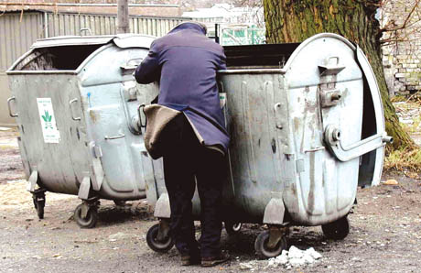*

TYPES OF POVERTY

**Absolute poverty** is a level of poverty at which certain minimum standards   
of living – for example for nutrition, health and shelter - cannot be met.

**Relative poverty** is the condition of having fewer resources or less income than others within a society or country, or compared to worldwide averages.

**Subjective poverty** is the perception by the individual as to whether she/he lives in poverty, or has what is necessary for a decent life.

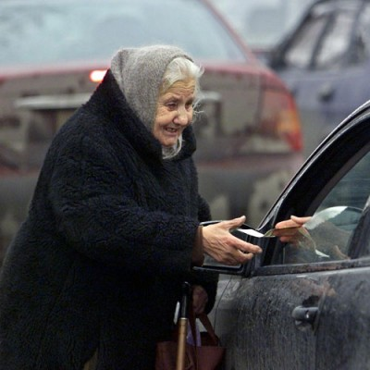

**P O V E R T Y IN P O L A N D**

**Causes of poverty:**

**A. Individual -** poverty is explained by individual circumstances and/or characteristic   
of poor people.

**Some examples are:**

amount of education, skill, experience, intelligence health, handicaps, age work orientation, time horizon, culture of poverty. discrimination, together with race, sex, etc.

**B. Aggregate -** poverty is explained by general, economy-wide problems, such as

* inadequate non-poverty employment opportunities
* inadequate overall demand (macro problems, macro policy)
* low national income

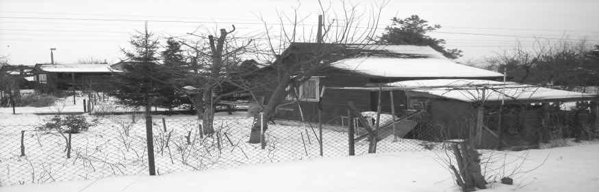

The number of Poles living under the poverty line   
is steadily increasing due to unemployment, inadequate education and too many dependents.

Office (GUS) report that shows that 2.2 million Poles live below the poverty line, mainly due to unemployment in   
the agricultural sector. The majority of this number come from the Podlasie region (eastern Poland), the Holy Cross region (south-central Poland) and the Lubelskie region (southeastern Poland).

Eurostat, the EU’s statistical agency, founds that two thirds of Poles cannot afford an annual holiday away from home and 21 percent are not able to have a meal with meat or fish every second day. As many as 17 percent   
of Poles cannot afford to own and run a car.

Seventeen percent of Poles are in the at risk category,   
or relatively deprived, and so socially excluded compared to other Poles. In this regard Poland is a normal country   
in the 27-nation bloc: seventeen percent is the average “  
at risk” figure for the whole of the European Union.

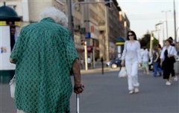

By the end of year 2009 the poverty line regulated   
by statue in Poland was 633 zł (163 Euro) for a one person household and 1709 zł (441 Euro) for a four person household.

**One child in five in Poland live at a risk   
of poverty**

According to the GUS report, in 2009, 22 percent of Polish children – over 650,000 people – lived in poverty. Within the EU, only Italy, Bulgaria, Romania and Latvia have   
a higher percentage of children existing in poverty.

***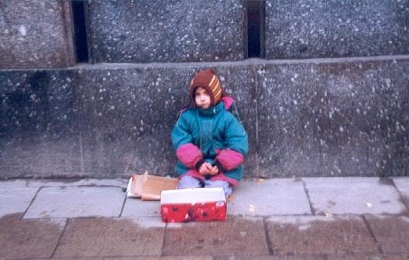***

**HOW WE COMBAT POVERTY IN P O L A N D ?**

**PKPP Lewiatan**   
focuses on regional and trade unions over 3,500 companies employing a total of over 600 thousand. people. He is a member of the Tripartite Commission for Socio-Economic. Belongs to the organization BUSINESSEUROPE - which is representative of the interests of entrepreneurs and employers to the European Commission, European Parliament and other EU institutions. ‘Effectively strive for a better law for Polish entrepreneurs, they care about their image. Monitor barriers to entrepreneurship and prepare our own macroeconomic.''

''What are their goals? ''

The most important postulates PKPP Lewiatan are:   
• Lower and simpler taxes   
• Lower labor costs   
• The liberalization of labor law   
• Reducing bureaucracy   
• Better economic law   
• Friendly business climate   
• Cheaper and more efficient state   
• The development of social dialogue

******

**Charity Campaign**

Since 2008, the Tesco Charity Campaign works with the Foundation for Children Happy Kids from Lodz. Our goal is to promote the idea of foster family care and assistance in the creation of new family homes.

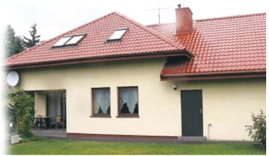  
For the past two years the Foundation helped Tesco to collect funds for a new family home of the child and foster family promoted the idea among customers, employees and business partners. Money was collected mainly through raising money for cans on counters in Tesco stores, selling a special edition postcards and encouraging customers and employees to deduct 1% tax for the Foundation. The action was also supported from its own resources Tesco.  
  
As a result of joint operations managed to collect an amount of more than 1-million of gold, through which the Foundation has purchased a suitable property and established a new family home of the child. This house is located in Lodz. From December 2009 to live in the foster parents who took the care and upbringing of seven children of Łódź orphanages.  
   
Tesco and the Foundation's action "Happy Kids" produced tangible results, not only in the form of a new family home of the child, but also in promoting the idea of foster family in Poland. According to a survey conducted among customers of Tesco, as much as 70% of them learned of the shares and supports the idea of foster family care, and more than 1 million customers took part in it. In addition to the research conducted among the 25 thousand workers of the crew Tesco that 80% knows and supports the action, and 50% take part in it.  
   
Foundation "Happy Kids" is a nonprofit organization, operating since 2001. It supports children who have found themselves in difficult situations, especially those who lost their real family. For them, the Foundation provides family homes, where they can once again find love and warmth. In the homes of the Foundation live and grow up as siblings, which until now have been separated and were housed in various homes throughout the Polish. Foundation is the only nongovernmental organization in Poland, who runs his own family homes. The new house is the 4th of its kind operating under the auspices of the Foundation, which already raises a total of 37 children.





Once again, our school starts in action "Help the children to survive the winter." The action is carried out before Christmas for children from large families, incomplete, broken home, being in a difficult situation and charges orphanages and centers for school-educational.

The voluntary collection of clothing, footwear, toys, books, food, suitable for long-term storage, cleaning agents, etc. may participate both individuals and businesses and community organizations. The Action is not possible to collect any funds.

Browse through a wardrobe, and bring all the clothes and shoes, mom, dad, sister, brother, and his own, which is no longer used, and which are not destroyed. These poor people will benefit many more years. If your home was a small child is also no longer need, bring toys, games, stuffed animals, cars, books, puzzles, etc. Take'll also cleaners: powders, lotions, soaps, toothpaste, scouring pastes, shampoos, diapers, sweets: chocolate bars, chocolate, biscuits, pasta, rice, cereal, salt, sugar, oil, tea, cocoa. Fill in the notebooks, pens, markers, crayons, modeling clay, books and school backpacks.

**POLSAT FUNDATION**

One of the largest NGOs operating on Polish territory, from the thirteen focus its assistance to the sick children and their parents.  
  
Illness of a child for many Polish families, not only in the drama of an emotional dimension, but also materially. Specialist treatment, modern pharmaceuticals and complex surgical procedures are associated with costs that often exceed the financial capacity of parents. National Health Service for various reasons is unable to surround the proper care to the needy. Polsat Foundation saves lives and health of children, who without her help they have no chance of recovery.  
  
The Foundation has created a system for rapid and effective response to requests for assistance. Information obtained from the parents shall be verified, and then their applications are processed according to established criteria. Money are spent on treatments, surgery, therapy and rehabilitation. To this day, the Foundation took over its 695 by 13 young patients and provided financial support to 997 hospitals and medical centers across the country that have been renovated and equipped with modern medical equipment. In total, the Foundation provided the statutory goals so far 152 878 611.64 zlotys. Funding for activities comes from the nationwide campaign, donations, grants many companies and individuals.  
  
The most recognizable projects include Polsat Foundation annual, nationwide campaigns organized jointly with the company Procter & Gamble under the slogan "Give the Children Sun," where the income is spent on the solution of specific problems of Polish pediatric centers. The Foundation also assumed the patronage of the program "Straight to Europe, including screening tests and preventive and therapeutic measures aimed at halting the formation of faulty posture in children. This year, the fourth time Polsat Foundation joined the program "Share a meal," organized jointly with Danone and the Federation of Polish Food Banks. Together with the Foundation's friend in June 2007, the Foundation has launched a new nationwide POLSAT social program "Family - House Love Built." The program aims to promote forms of family foster care by assisting local governments, which deliberately and consistently implement a plan to create systemic solutions for the care of child and family.  
  
In January 2005, the Foundation organized a fundraiser Polsat for children who suffered after undergoing the tsunami in Asia. Foundation provided the Polish Humanitarian over 1 million 200 thousand pounds on aid to children in Sri Lanka, one of the regions hardest hit by the tsunami.  
  
In June 2005, after the successful action, organized jointly with the creators of the show "Just Life", the Foundation has purchased 12 Polsat cochlear implants for deaf children. Children have already been operated on at the International Center for Hearing and Speech in Kajetany near Warsaw.  
  
The Foundation was also the patron saint of television program Fri "Our Children", which is deliberately and consistently takes the often very difficult topics, he talked about the problems of children and adolescents. Formula One program allows a trial to determine the causes and seek solutions to the problems described. The aim of its promoters was not only a show, but to help. Support was directed at children - those most vulnerable and helpless against the misconduct of their supervisors or the absurdities of the Polish legal system.

***Hungry children are not thinking about science***

  
In September 1998, Polish Humanitarian Organisation has launched a program of feeding children in schools, the north-eastern Polish. It consists of a daily school meal funding of children from the poorest families. Today, the "Puppet" covers the entire country.

The action is an important element of the BP partner club, a modern model of a marketing policy, which - through collaboration with the PHO BP - to join the clients to share the social welfare "Puppet." Each program participant may transfer partner club BP accumulated points for feeding children. One meal is the equivalent of 140 points. BP and its customers for six years, the lunch program for children dedicate nearly two million.



**CARITAS**

Caritas is a love based on brotherhood, designed to raise and support and accept all of the needy. This form of love with such assistance, which is shipped as far as possible to all in need - the poor and weak declining. There are important racial motives here, and also connected with religion or ethnic origin. The most important   
is the opening of the ordinary for them to needy and oppressed others.



**THE GREAT ORCHESTRA OF CHRISTMAS CHARITY**

The aim of the Foundation The Great Orchestra of Christmas Charity active in the field of health, which consists of saving the lives of ill people, especially children, and action to improve their health, as well as to work for health promotion and disease prevention.  
Pursue this objective by The final collection, purchase of equipment at medical units of hospitals throughout Poland, as well as by conducting five national medical programs and one educational.Słuchaj

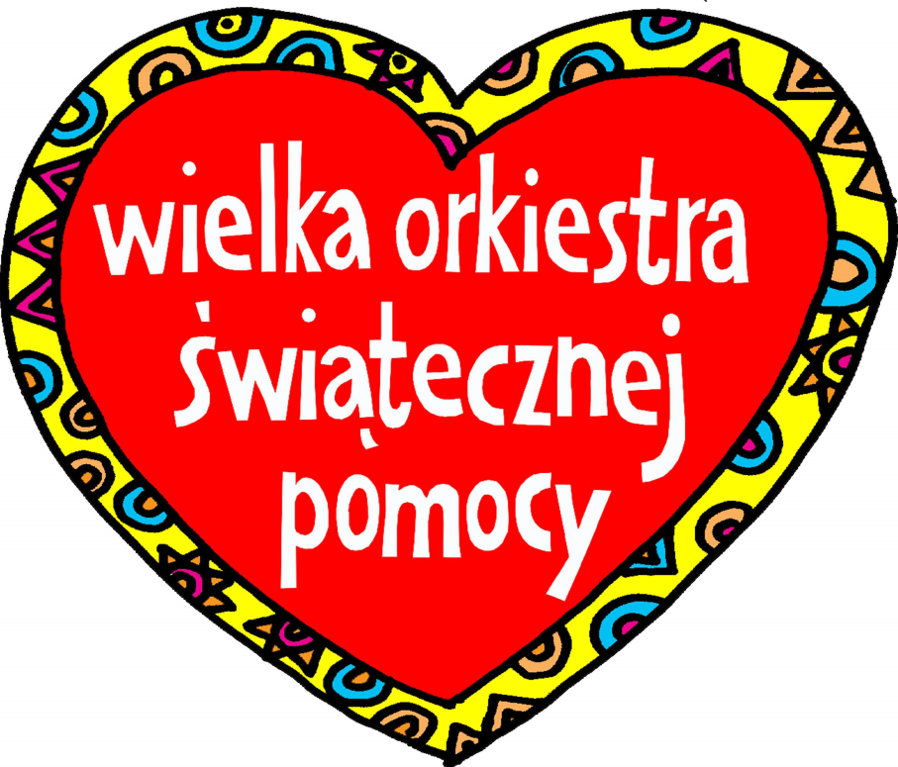Zapis fonetyczny

**POLISH RED CROSS**

Polish Red Cross is the oldest humanitarian organization in Poland. They are everywhere in the name of humanity - its chief principle, can give people joy and hopeimprove their fortunes. PCK is primarily the people creating it - employees and nearly 500 thousand. support their members, volunteers (mostly young).  
The basic statutory duties PCK is to work for the needy, to sensitize the public on the wrong man, and promote the idea of bringing the selfless help.

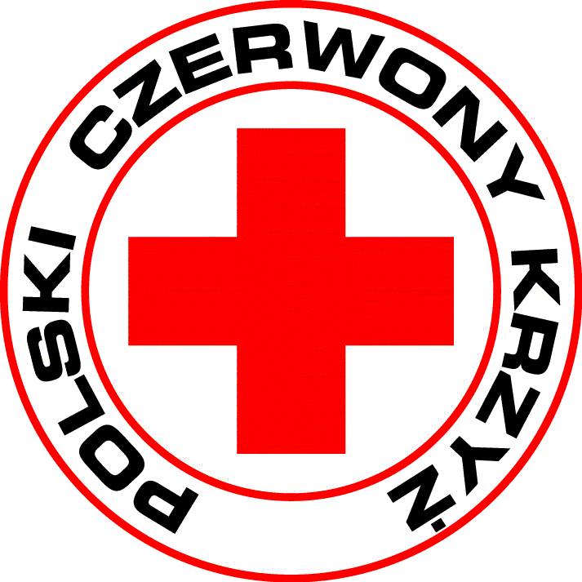

**Brotherhood of Charity them. St. Albert**

Brotherhood of Charity them. St. Albert Lublin supports people in need of assistance since 1983 (base took its current name in 1991.). Association takes care of the poor, sick, disabled, homeless, dependent, refugees and all those who need this assistance. With the aid of the Society also benefit pensioners, large families and single mothers who are getting a small income. Brotherhood of Charity them. St. Albert's help all the needy.



**Charitable Foundation, "Help For Poor"**

GOALS of THE FOUNDATION:

1. Statutory objective of the Foundation "Help for poor" is charity in the sphere of public benefit, involving in particular:

* assistance to families and individuals in financial difficulty
* self-supporting attitudes out of poverty
* help children and young talented and coming from poor families in gaining education and occupation
* the organization of recreation for children from poor and pathological families
* supporting actions to address pathologies among children and adolescents
* support the activities of organizations and institutions engaged in activities for the poor
* material assistance in situations of chance

2. The activities of the Foundation is a registered public benefit activities as defined in the Act of 04/24/2003 on the public benefit and volunteer work, and can only be conducted as a voluntary activity. Such activity is the sole statutory activities of the Foundation. Outside this sphere of the Foundation shall not engage in any activity.

3. Foundation conducts charitable registered solely for the benefit of people in a difficult situation or material in relation to societya.

The idea to establish the existence of a Charitable Foundation, appeared in the context of the approaching Christmas in 2007. Christmas is so sporadic and it seemed to be like the ocean needs. For that reason they decided to establish the existence of a foundation that will help for the most needy throughout the year. Thanks to the generosity of the founder, and with the cooperation of the parish in Bierach the charity was able to take the registration procedure.



**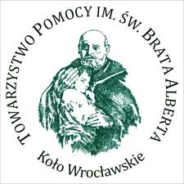Aid Society of The Name of St. Albert**

Is an independent Catholic charity organization.

The Society aims to help homeless and the poor - in the spirit of it’s Patron, Saint. Brother Albert. It is the first Polish non-governmental organization, who had taken up with the homeless. Until 1989 it was called the Aid Society. Adam Chmielowski. It unites 2900 members organized in 61 circles. Each wheel is trying to organize shelter, food or other assistance to homeless people and the poor.

They have seek to apply and act according to one rule:

*"... Give food to every hungry, homeless place, and clothes the naked man. If you can't many, give a little”*

**Despite Everything**

**Foundation ‘’Despite Everything " founded the Anna Dymna 26 September 2003 in Krakow. The Foundation was established to rescue a groups of adults with intellectual disabilities, residents of the hostels.** 

***Noble Pack***

****

**It is a special, nationwide campaign of support - implemented since 2001 by the Association SPRING. Its main objective is to carry the idea of direct aid - that it was effective, concrete and meaningful.**

***ACTIVITY***

They reach with the help of the families most in need. In particular, they get to large families, disabled, with a sick or disabled children or family members, the elderly and the lonely, the families who suffer and whose poverty is culpable.

**POLISH HUMANITARIAN ACTION**

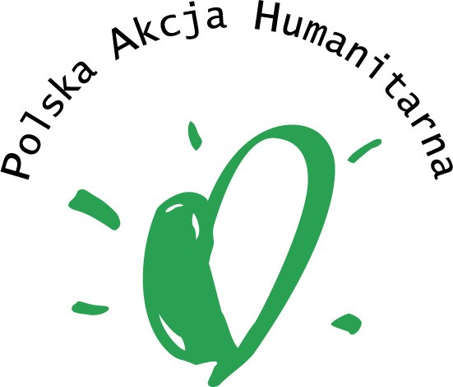

….Their mission is to make the world a better place by reducing suffering and promoting humanitarian values…….

It helps people in crisis situations as soon as possible obtaining of initiative and acceptance of responsibility for their own future. They focus on the Polish society, shaping the humanitarian attitudes, and building a modern culture of mutual help. The guiding principle of the organization is to function effectively with respect for human dignity. Since the beginning of the Foundation is to provide assistance regardless of nationality, race or religion.

**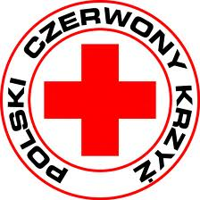 Polish Red Cross**

It is the Polish member of [International Red Cross and Red Crescent Movement](http://en.wikipedia.org/wiki/International_Red_Cross_and_Red_Crescent_Movement). It was founded in 1919 by Doctor Benjamin Reschovsky of Warsaw City Hospital   
and recognized by the Red Cross on July 24th 1919 and it’s first president was [Paweł Sapieha](http://en.wikipedia.org/w/index.php?title=Pawe%C5%82_Sapieha&action=edit&redlink=1" \o "Paweł Sapieha (page does not exist)).

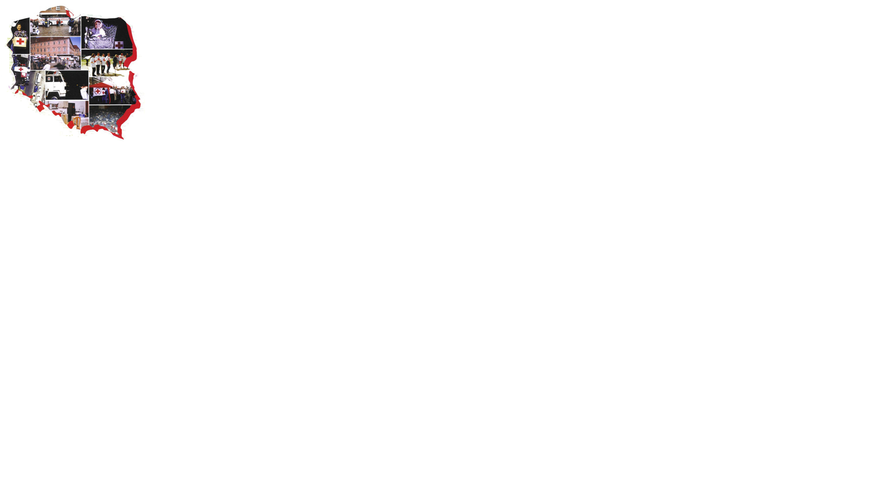

**FRANCE**

**Organisation full legal name:**

**LEGT Etienne Oehmichen**

**Type of organisation: General Secondary School**

**City: Chalons en Champagne**

**COMENIUS 2010-2012**

**POVERTY IN FRANCE**

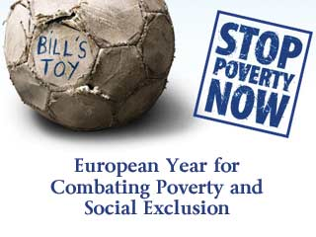

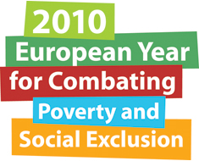 

**Lycée Etienne Oehmichen Châlons-en-Champagne / FRANCE**

**<http://www.lyc-oehmichen.ac-reims.fr/>**

**[Agence 2e2f - L'agence pour la mobilité internationale et européenneMarianne](http://www.2e2f.fr/index.php)[Programme pour l'education et de formation tout au long de la vie](http://ec.europa.eu/education/index_fr.htm)**

**“Europe joins forces to fight poverty and social exclusion**

Almost 84 million Europeans live at risk of poverty, which means they face insecurity, and go without what most people often take for granted.

Inspired by its founding principle of solidarity, the European Union has joined forces with its Member States to make **2010** the **European Year For Combating Poverty and Social Exclusion**. The key objectives were to raise public awareness about these issues and renew the political commitment of the EU and its Member States to combat poverty and social exclusion.

National and local events took place in every EU Member State, plus Norway and Iceland. Activities included awareness raising campaigns, workshops and information seminars in schools. Films, magazines and other information material were produced to help people understand how poverty and social exclusion affect their communities, and for those directly affected, increase awareness of their rights.”

**Some figures**

Our social protection systems are among the most highly-developed in the world and yet,

today, many Europeans still live in poverty.

• 79 million people live below the poverty line (set at 60% of their country's median

income). That represents 16%-17% of Europe's population.

• One European in ten lives in a household where nobody works.

• For 8% of Europeans, having a job is not enough to work one's way out of

poverty.

• In most Member States, children are more exposed to this scourge than the rest

of the population: 19% of children live under the threat of poverty.

<http://www.2010againstpoverty.eu/>

**What is poverty?**

Poverty is the state of having little or no money to afford basic human needs such as food, access to drinking water, health care, clothes, accommodation, education and good living conditions in general.

Figures in France (2008):

* between 4.3 and 7.8 million people
* 7.1% to 13.2% of total population
* 9th rank in Europe
* official poverty threshold : 878€ per month for a single person

Figures in Europe (2008) :

* 82 millions European citizens
* 16.5%

**Who are the poor in France?**

* **The working poorPoverty : the state of having little or no money and few or no material possession**

Having a job does not always protect people from the risk of poverty. In-work poverty is linked to low pay, low skills, precarious employment and often involuntary part-time working. The working poor are often distinguished from the poor who are supported by government aid or charity. 8.5% in Europe and 6.5% in France.

* **The Elderly**

There are about 990,000 people (10% of pensioners) above 65 years old living below the poverty threshold. 600,000 elderly people depend on the minimum pension given by the government. This number has been increasing and their situation is worsening.

* **Children and young adults**

Half the poor are less than 30 years old:

* one child out of ten lives
* 12.7% of 20-24 year-olds
* 700,000 of 20-29 year-olds
* **Women**

The female poverty rate is at 7.4% whereas male poverty is at 6.9%. They represent 53.5% of the poor.

* **Single parent households**

Without social transfers, 46% of single parent households live below the poverty line. Most of these single parents are single mothers.

* **Immigrants**

This population has the worst poverty figures. The rates are almost three times higher than the average population’s poverty rate.

* **The uneducated**

The lack of diploma is a serious handicap in France and source of unemployment.

|  |  |
| --- | --- |
|  | Poverty rate |
| * No diploma | 7.5% |
| * Diploma of Higher Education (2 years after the baccalaureate) | 3.2% |
| * Working class | 8% |
| * Executives | 1.5% |

***Poverty map***

| **pauvrete_region_4-2.jpg** |
| --- |
|  |

[www.inegalites.fr](http://www.inegalites.fr)

Alternatives Internationales, Hors Série n°8, December 2010

**THE WELFARE STATE**

**KEY TOOL TO COMBAT POVERTY**

**LOCAL POLICIES**

The local council proposes various aids to help people solve their financial and social problems.

**Food**

In case of emergency the CCAS (Centre Communal d’ Action Sociale – Local social action centre) gives a check to people to enable them to buy food in specific stores.

“Le Marché de Pauline” is a social supermarket. Its customers are families and single people who depend on social aids. The products are sold 10% of their value. The beneficiaries can also participate in cooking, Do-It-Yourself, budgeting and health workshops with social workers.

**Housing**

Stabilization accommodation: an emergency shelter is offered single women or couples without children in serious financial difficulty.

Temporary accommodation: for single people (men or women), families, battered women...

Social rehabilitation accommodation centre: for a period of 3 to 9 months, this centre accommodates, supports and accompanies people in great financial straits.

**Emergency number: 115**

Toll free, 24/7, to help the homeless and people sleeping in the streets.

**The CCAS (**Centre Communal d’Action Sociale)

Three hundred employees (social workers, educators, councillors, nurses, doctors…) work in this public structure to assist and help the families of the district. It is subsidized by the government, the local council and private donations.

Its actions are varied:

* day care centers for children under six
* social aids
* RSA (revenu de solidarité active ) – a social benefit aimed at completing low salaries and encouraging beneficiaries to work in order to get out of the total assistance system
* emergency financing to pay electricity bills
* food coupons

**Le Contrat urbain de cohésion sociale – Urban contract for Social Cohesion**

**Offrir une chance à chacun – Everyone is given a chance (no one is to be left out)**

The Urban contract for Social Cohesion of Châlons-en-Champagne is a set of actions to help six socially underprivileged neighborhoods. The contract was signed between the City, the government, Social housing and local associations.

The contract is set upon five major priorities:

* The access to employment
* Local economic development
* Housing and living conditions
* Citizenship and prevention of juvenile delinquency
* Health and education

***How does the Regional Council fight against poverty?***

The Champagne Ardenne Regional Council:

* organizes meetings with local firms to prevent outsourcing of activities and jobs
* shelters for the homeless in winter
* rehabilitation and building of affordable housing

**GOVERNMENT POLICIES OF REDISTRIBUTION**

One of the responsibilities of the state government is to pursue actions aiming at reducing inequalities and the rate of poverty in the country. The origin of social protection in France dates back to medieval times, with [fraternal benefit societies](http://en.wikipedia.org/wiki/Fraternal" \o "Fraternal). In the second half of the nineteenth century, systems of [social assistance](http://en.wikipedia.org/wiki/Social_assistance" \o "Social assistance) developed gradually, often launched by employers marked by [social awareness](http://en.wikipedia.org/wiki/Social_Catholicism" \o "Social Catholicism), then relayed by the first laws. In the early 20th century, modern [social insurance](http://en.wikipedia.org/wiki/Social_insurance" \o "Social insurance) was created, offering employees protection against certain risks: accidents, sickness, disability, maternity, old age, death ... During the Second World War, the National Council of Resistance designed the system of [Social security](http://en.wikipedia.org/wiki/Social_security" \o "Social security), now at the heart of social protection. It was created just after the Liberation, by an order of 4 October 1945, followed by other texts.

Government policy frameworks have since been trying to limit growth in income inequality. Government social policy involves social welfare and protection through a system of redistribution. This redistribution can be pursued through taxation, social transfers and investment in education, health and other social services.

In France, the [welfare system](http://en.wikipedia.org/wiki/Welfare_system" \o "Welfare system) costs an annual €500 billion or more than 30% of GDP.

Social transfers (such as unemployment, family and housing benefits, free education…) can reduce the risk of poverty by 38%.

**Taxation**

* Personal income taxes
* Property taxes
* Corporate taxes
* VAT
* …

**Social transfers**

* Assistance benefits (Minimum revenue, Aid to Single mothers, Housing benefits, Minimum pensions, unemployment insurance, sickness benefits…)
* Social insurance
* …

**Health care**

In the field of social protection, 1999 was characterized in France by the creation of universal

sickness cover (CMU) providing everyone, including the most disadvantaged, with access to

health care.

A universal entitlement to basic sickness cover on the criteria of residence and which is immediate and permanent and may be free or otherwise depending on the means of the

beneficiary. All stable and regular residents in France will automatically become members of

the general sickness insurance scheme if they do not already hold an entitlement under another basic scheme, notably linked to a professional activity.

Basic medical treatment is free.

**Social housing**

 Social housing - HLM (*Habitation à Loyer Modéré*) – is intended for families and households whose resources are below a fixed threshold. The income threshold for assessment of eligibility for social housing varies by location and household size. For a family of four in Paris the maximum threshold is around €43,000 a year whilst in the regions it is around €31,000. Tenants of social housing must face a test of their resources every three years. If their income is above an income threshold, they are required to pay an extra charge.

The 'right to housing' in France implies that disadvantaged people suffering poverty or housing difficulty enjoy priority access to social housing. However, people actually have serious difficulty obtaining access to social housing in France, especcially in Paris. The 'opposable' right to housing could help some disadvantaged groups, though it has significant limitations.

The Solidarity and Urban Renewal (SRU) Act requires local authorities with more than 35,000 inhabitants (1,500 in the Paris region) to ensure that at least 20 percent of all housing will be social housing by 2020. Some municipalities are thus compelled by law to boost their public housing stocks over a 20-year period or face fines but many are choosing to ignore this obligation. Towns that fail to achieve this goal would be subject to a fine of 152 euros per unit of housing below the quota.

Yet, some prefer to pay fines rather than invest in deeply unpopular social housing projects because paying the fines is cheaper and helps win votes.

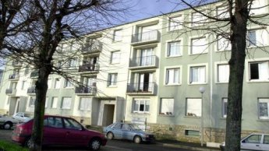

<http://www.french-property.com/>

<http://www.france24.com/>

http://www.ilo.org/public/english/bureau/inst/publications/discussion/dp19408.pdf

**MICROFINANCE**

It is a system intended for [low-income](http://en.wikipedia.org/wiki/Low-income" \o "Low-income) clients who traditionally lack access to [banking](http://en.wikipedia.org/wiki/Banking" \o "Banking) and related services.

More broadly, it is a movement whose object is "a world in which as many poor and near-poor households as possible have permanent access to an appropriate range of high quality financial services, including not just credit but also savings, insurance, and fund transfers.”

Those who promote microfinance generally believe that such access will help poor people out of poverty.

Often people don't have enough money when they face a need, so they borrow. A poor family might borrow from relatives to buy land, from a moneylender to buy rice, or from a microfinance institution to buy a sewing machine.

Most needs are met through mix of saving and credit.

**Funding needs:**

* Lifecycle Needs: such as weddings, funerals, childbirth, education, homebuilding, widowhood, old age.
* Personal Emergencies: such as sickness, injury, unemployment, theft, harassment or death.
* Disasters: such as fires, floods, cyclones and man-made events like war or bulldozing of dwellings.
* Investment Opportunities: expanding a business, buying land or equipment, improving housing, securing a job (which often requires paying a large bribe),

In France there are two types of microcredits:

**Personal microcredit or social microfinance**

It is a loan of less than €3,000 with an average rate of 3.5% to finance small personal projects (driving license, car, house equipments…). This loan is intended for people who cannot get personal loan at the bank. The personal microcredit is also called social microcredit because the beneficiary is always unemployed or a working poor. The money is to be paid back in small installments. People thus feel they are trustworthy.

**Professional microcredit**

This loan of less than €25,000 is intended for those willing to create or take over a business but do not have enough financial guaranties to obtain a standard loan. To benefit from this type of loan, the borrower must be supported by a network of specialized counselor agencies (France Initiative, France Active, Boutiques de Gestion, Fondation 2ème chance) whose work is to help build up the project and study the business plan.

**A NON-GOVERNMENTAL AGENCYNon-governmental organization**

A non-governmental organization (NGO) is a legally constituted organization created by [natural](http://translate.google.com/translate?hl=fr&sl=fr&tl=en&prev=_t&u=http://en.wikipedia.org/wiki/Natural_person" \o "Natural person) or [legal persons](http://translate.google.com/translate?hl=fr&sl=fr&tl=en&prev=_t&u=http://en.wikipedia.org/wiki/Legal_person" \o "Legal person) that operates independently from any [government](http://translate.google.com/translate?hl=fr&sl=fr&tl=en&prev=_t&u=http://en.wikipedia.org/wiki/Government" \o "Government) and a term usually used by governments to refer to entities that have no government status. A Non-Governmental Organization (NGO) is a legally constituted organization that operates independently from any [government](http://translate.google.com/translate?hl=fr&sl=fr&tl=en&prev=_t&u=http://en.wikipedia.org/wiki/Government" \o "Government). However it can be funded partially or totally by governments.

According to the World Bank, they are private organizations that pursue activities to relieve suffering, promote the interests of the poor, protect the environment, provide basic social services, or undertake community development.

**Croix Rouge Française :French Red Cross:**

* **Date de création :** En Mai 1864. **Creation date:** In May 1864.
* **Siège :** Paris, France. **Headquarters:** Paris, France.
* **Président / Responsable :** [Jean-François Mattei](http://translate.google.com/translate?hl=fr&sl=fr&tl=en&prev=_t&u=http://fr.wikipedia.org/wiki/Jean-Fran%25C3%25A7ois_Mattei) . **President / Manager:** [Jean-Francois Mattei](http://translate.google.com/translate?hl=fr&sl=fr&tl=en&prev=_t&u=http://fr.wikipedia.org/wiki/Jean-Fran%25C3%25A7ois_Mattei)
* **Logo :** **Logo:**

[Cross logo rouge.jpg](http://translate.google.com/translate?hl=fr&sl=fr&tl=en&prev=_t&u=http://fr.wikipedia.org/wiki/Fichier:Logo_Croix_rouge.j)[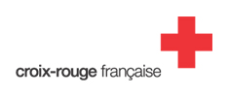](http://fr.wikipedia.org/wiki/Fichier:Logo_Croix_rouge.j)

Fondée en 1864, La Croix-Rouge française est une association loi 1901, [reconnue d'utilité publique](http://translate.google.com/translate?hl=fr&sl=fr&tl=en&prev=_t&u=http://fr.wikipedia.org/wiki/Reconnaissance_d%2527utilit%25C3%25A9_publique" \o "Recognition of public utility) depuis [1945](http://translate.google.com/translate?hl=fr&sl=fr&tl=en&prev=_t&u=http://fr.wikipedia.org/wiki/1945" \o "1945) . Founded in 1864, the French Red Cross is an association, [recognized of public utility](http://translate.google.com/translate?hl=fr&sl=fr&tl=en&prev=_t&u=http://fr.wikipedia.org/wiki/Reconnaissance_d%2527utilit%25C3%25A9_publique" \o "Recognition of public utility) since [1945](http://translate.google.com/translate?hl=fr&sl=fr&tl=en&prev=_t&u=http://fr.wikipedia.org/wiki/1945" \o "1945). Son fonctionnement est défini dans les statuts adoptés par l'assemblée généraleActeur de référence dans le domaine de l'action humanitaire, la Croix-Rouge française mène des actions pour venir en aide aux personnes en difficulté en France et à l'étranger. It was founded to protect human life and health, to ensure respect for all [human](http://en.wikipedia.org/wiki/Human" \o "Human) beings, and to prevent and alleviate human suffering, without any discrimination based on [nationality](http://en.wikipedia.org/wiki/Nationality" \o "Nationality), [race](http://en.wikipedia.org/wiki/Race_(classification_of_human_beings)" \o "Race (classification of human beings)), [sex](http://en.wikipedia.org/wiki/Gender" \o "Gender), [religious](http://en.wikipedia.org/wiki/Religion" \o "Religion) beliefs, [class](http://en.wikipedia.org/wiki/Social_class" \o "Social class) or [political](http://en.wikipedia.org/wiki/Politics" \o "Politics) opinions.

In the field of humanitarian action, the French Red Cross carries out actions to help needy people in France and abroad. S'appuyant sur plus de 50.000 [bénévoles](http://translate.google.com/translate?hl=fr&sl=fr&tl=en&prev=_t&u=http://fr.wikipedia.org/wiki/B%25C3%25A9n%25C3%25A9voles" \o "Volunteer) et 17.000 salariés, l'association met en œuvre au quotidien tous les moyens à sa disposition pour remplir les missions qu'elle s'est fixée. With more than 50,000 [volunteers](http://translate.google.com/translate?hl=fr&sl=fr&tl=en&prev=_t&u=http://fr.wikipedia.org/wiki/B%25C3%25A9n%25C3%25A9voles" \o "Volunteer) and 17,000 employees, it is highly effective.

Model Adriana Karembeu is godmother of the association the French Red Cross.

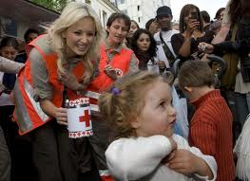

****

* **Actions** :
  + food aid – 30,000,000 meals are distributed each year
  + 45 structures in France
  + 1,500 shelter accommodations

[www.croix-rouge.fr](http://www.croix-rouge.fr)

**CHARITIES**

They are charitable associations whose generous actions or donations aid [the](http://dictionary.reference.com/browse/the) poor, ill, helpless or homeless.ACF-France est membre d'un réseau international (ACF International) avec quatre autres organisations : Action Against Hunger-UK dont le siège est à [Londres](http://translate.google.com/translate?hl=fr&sl=fr&tl=en&prev=_t&u=http://fr.wikipedia.org/wiki/Londres" \o "London) , Accion contra el hambre à [Madrid](http://translate.google.com/translate?hl=fr&sl=fr&tl=en&prev=_t&u=http://fr.wikipedia.org/wiki/Madrid" \o "Madrid) , Action Against Hunger-US et Action contre la faim-Canada à [Montréal](http://translate.google.com/translate?hl=fr&sl=fr&tl=en&prev=_t&u=http://fr.wikipedia.org/wiki/Montr%25C3%25A9al" \o "Montreal) .

**Secours populaire :Secours populaire:**

* **Date de création :** En 1945. **Creation date:** In 1945.
* **Siège :** 9/11 [rue Froissart](http://translate.google.com/translate?hl=fr&sl=fr&tl=en&prev=_t&u=http://fr.wikipedia.org/wiki/Rue_Froissart_(Paris)) , [Paris](http://translate.google.com/translate?hl=fr&sl=fr&tl=en&prev=_t&u=http://fr.wikipedia.org/wiki/Paris) , [Île-de-France](http://translate.google.com/translate?hl=fr&sl=fr&tl=en&prev=_t&u=http://fr.wikipedia.org/wiki/%25C3%258Ele-de-France) . **Headquarters:** 9 / 11 [rue Froissart](http://translate.google.com/translate?hl=fr&sl=fr&tl=en&prev=_t&u=http://fr.wikipedia.org/wiki/Rue_Froissart_(Paris)) , [Paris](http://translate.google.com/translate?hl=fr&sl=fr&tl=en&prev=_t&u=http://fr.wikipedia.org/wiki/Paris) , [Île-de-France](http://translate.google.com/translate?hl=fr&sl=fr&tl=en&prev=_t&u=http://fr.wikipedia.org/wiki/%25C3%258Ele-de-France) .
* **Président / Responsable :** [Julien Lauprêtre](http://translate.google.com/translate?hl=fr&sl=fr&tl=en&prev=_t&u=http://fr.wikipedia.org/wiki/Julien_Laupr%25C3%25AAtre) . **President / Manager:** [Julian Lauprêtre](http://translate.google.com/translate?hl=fr&sl=fr&tl=en&prev=_t&u=http://fr.wikipedia.org/wiki/Julien_Laupr%25C3%25AAtre) .
* **Slogan :** « Tout ce qui est humain est nôtre » **Slogan:** "All that is human is ours"
* **[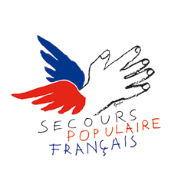](http://fr.wikipedia.org/wiki/Fichier:Logo-spf-2009.g)Logo :** **Logo:**

[Spf-logo-2009.gif](http://translate.google.com/translate?hl=fr&sl=fr&tl=en&prev=_t&u=http://fr.wikipedia.org/wiki/Fichier:Logo-spf-2009.g) Created in 1945, the People's Relief Association is non profitable. It is financed by donations. L'association s'est donné pour mission d'agir contre la pauvreté et l'exclusion en France et dans le monde. The association's mission is to act against poverty and exclusion in France.



www.secourspopulaire.fr

[http://upload.wikimedia.org/wikipedia/fr/7/75/Logo_Pharmaciens_Sans_Fronti% C3% A8res.jpg](http://translate.google.com/translate?hl=fr&sl=fr&tl=en&prev=_t&u=http://fr.wikipedia.org/wiki/Fichier:Logo_Pharmaciens_Sans_Fronti%C3%A8res.j)**Secours catholique :Secours catholique :**

* **Creation date:** [8](http://translate.google.com/translate?hl=fr&sl=fr&tl=en&prev=_t&u=http://fr.wikipedia.org/wiki/8_septembre) [September](http://translate.google.com/translate?hl=fr&sl=fr&tl=en&prev=_t&u=http://fr.wikipedia.org/wiki/Septembre) [1946](http://translate.google.com/translate?hl=fr&sl=fr&tl=en&prev=_t&u=http://fr.wikipedia.org/wiki/1946" \o "1946) .
* **Siège :** [Paris](http://translate.google.com/translate?hl=fr&sl=fr&tl=en&prev=_t&u=http://fr.wikipedia.org/wiki/Paris) , [France](http://translate.google.com/translate?hl=fr&sl=fr&tl=en&prev=_t&u=http://fr.wikipedia.org/wiki/France) . **Headquarters:** [Paris](http://translate.google.com/translate?hl=fr&sl=fr&tl=en&prev=_t&u=http://fr.wikipedia.org/wiki/Paris) , [France](http://translate.google.com/translate?hl=fr&sl=fr&tl=en&prev=_t&u=http://fr.wikipedia.org/wiki/France" \o "France) .
* **Président / Responsable :** [François Soulage](http://translate.google.com/translate?hl=fr&sl=fr&tl=en&prev=_t&u=http://fr.wikipedia.org/wiki/Fran%25C3%25A7ois_Soulage) . **President / Manager:** [Relieves Francis](http://translate.google.com/translate?hl=fr&sl=fr&tl=en&prev=_t&u=http://fr.wikipedia.org/wiki/Fran%25C3%25A7ois_Soulage) .
* **Logo :** **Logo:**

[Logo Block-Catholique-Caritas-France.gif](http://translate.google.com/translate?hl=fr&sl=fr&tl=en&prev=_t&u=http://fr.wikipedia.org/wiki/Fichier:Logo-Secours-Catholique-Caritas-France.g)[Logo-Secours-Catholique-Caritas-France.gif](http://fr.wikipedia.org/wiki/Fichier:Logo-Secours-Catholique-Caritas-France.g)

Le Secours catholique est une association à [but non lucratif](http://translate.google.com/translate?hl=fr&sl=fr&tl=en&prev=_t&u=http://fr.wikipedia.org/wiki/Association_%25C3%25A0_but_non_lucratif" \o "Non-profit association) créée le [8](http://translate.google.com/translate?hl=fr&sl=fr&tl=en&prev=_t&u=http://fr.wikipedia.org/wiki/8_septembre" \o "September 8) [septembre](http://translate.google.com/translate?hl=fr&sl=fr&tl=en&prev=_t&u=http://fr.wikipedia.org/wiki/Septembre" \o "September) [1946](http://translate.google.com/translate?hl=fr&sl=fr&tl=en&prev=_t&u=http://fr.wikipedia.org/wiki/1946" \o "1946) par l'abbé [Jean Rodhain](http://translate.google.com/translate?hl=fr&sl=fr&tl=en&prev=_t&u=http://fr.wikipedia.org/wiki/Jean_Rodhain" \o "Jean Rodhain) [[1]](http://translate.google.com/translate?hl=fr&sl=fr&tl=en&prev=_t&u=http://fr.wikipedia.org/wiki/Secours_catholique%23cite_note-0" \l "cite_note-0) . This Catholic Aid Association was created on [8](http://translate.google.com/translate?hl=fr&sl=fr&tl=en&prev=_t&u=http://fr.wikipedia.org/wiki/8_septembre" \o "September 8) [September](http://translate.google.com/translate?hl=fr&sl=fr&tl=en&prev=_t&u=http://fr.wikipedia.org/wiki/Septembre" \o "September) [1946](http://translate.google.com/translate?hl=fr&sl=fr&tl=en&prev=_t&u=http://fr.wikipedia.org/wiki/1946" \o "1946) by Father [Jean Rodhain](http://translate.google.com/translate?hl=fr&sl=fr&tl=en&prev=_t&u=http://fr.wikipedia.org/wiki/Jean_Rodhain" \o "Jean Rodhain). Le Secours catholique est surtout attentif aux problèmes de pauvreté et d'exclusion et cherche à promouvoir la justice sociItIt It is especially watchful to problems of poverty and exclusion, and seeks to promote social justice.

[Reconnue d'utilité publique](http://translate.google.com/translate?hl=fr&sl=fr&tl=en&prev=_t&u=http://fr.wikipedia.org/wiki/Reconnaissance_d%2527utilit%25C3%25A9_publique" \o "Recognition of public utility) en [1962](http://translate.google.com/translate?hl=fr&sl=fr&tl=en&prev=_t&u=http://fr.wikipedia.org/wiki/1962" \o "1962) , l'association a été déclarée grande cause nationale en [1988](http://translate.google.com/translate?hl=fr&sl=fr&tl=en&prev=_t&u=http://fr.wikipedia.org/wiki/1988" \o "1988) . [State-approved](http://translate.google.com/translate?hl=fr&sl=fr&tl=en&prev=_t&u=http://fr.wikipedia.org/wiki/Reconnaissance_d%2527utilit%25C3%25A9_publique" \o "Recognition of public utility) in [1962](http://translate.google.com/translate?hl=fr&sl=fr&tl=en&prev=_t&u=http://fr.wikipedia.org/wiki/1962" \o "1962), the association has been declared of national utility in [1988](http://translate.google.com/translate?hl=fr&sl=fr&tl=en&prev=_t&u=http://fr.wikipedia.org/wiki/1988" \o "1988). Elle établit aussi des rapports pour l'information du gouvernement, en matière sociale notamment.ItII

Elle constitue la branche française du réseau [Caritas Internationalis](http://translate.google.com/translate?hl=fr&sl=fr&tl=en&prev=_t&u=http://fr.wikipedia.org/wiki/Caritas_Internationalis" \o "Caritas Internationalis) . It is the French branch network of [Caritas Internationalis](http://translate.google.com/translate?hl=fr&sl=fr&tl=en&prev=_t&u=http://fr.wikipedia.org/wiki/Caritas_Internationalis" \o "Caritas Internationalis).http://www.google.com/images/infowindow/iws_n.png

Its volunteers help families get in touch with social services. Access to decent housing is one of the organization’s main objectives.http://www.google.com/images/infowindow/iws_n.png

http://www.google.com/images/infowindow/iws_w.png

http://www.google.com/images/infowindow/iws_e.png

http://www.google.com/images/infowindow/iws_s.png

http://www.google.com/images/infowindow/iws_s.png



http://www.google.com/images/infowindow/iw_n.png

http://www.google.com/images/infowindow/iw_n.png

http://www.google.com/images/infowindow/iw_w.png

http://www.google.com/images/infowindow/iw_e.png

http://www.google.com/images/infowindow/iw_s0.png

http://www.google.com/images/infowindow/iw_s0.png



http://www.google.com/images/logo_smallest.png

**Texte français original:**

Estimant que la politique de neutralité et de réserve de la Croix-Rouge avait été une erreur, ils voulurent fonder une association qui allierait aide humanitaire et actions de sensibilisation auprès des médias et des institutions politiques.

http://www.google.com/images/zippy_plus_sm.gifProposer une meilleure traduction

**GERMANY**

**Organisation full legal name:**

**Theodor-Heuss-Schule**

**Type of organisation: General Secondary School**

**City: Marburg**

# Our ideas to combate poverty

1. **A good education for every child**

We think that a good education is the best basis for not to fall into poverty in future life. Because of this the government has to make sure that the school system gives everyone a chance to learn according to one’s abilities. Especially children from a poorer background or a deprived area should be given special help in any respect to gain a good education.

1. **Support parents**

Parents should be given enough money by the state to feed their children and allow them to take part in social life. For example they should get cheques for being able to buy all essential things students need for school. There should be a free meal for them at school every day. It must be possible that students are taken care of after lessons without having to pay for this service. In order to make them able to join sports’ clubs or any other cultural institutions vouchers must be given to them. For some parents it would be necessary to have help by professional social workers to learn how to organize their life or have tuition how to raise their children.

1. **A raise in Hartz IV**

Each person and each family should have enough money to have an appropriate standard of living. That includes food and drink, decent home, clothing and the possibility to participate in some culture events. Especially large families and single parents belong to the poor groups in our society. Because of this they really need a more extensive support.

1. **Minimize unemployment**

In order to reduce the poverty rate more and better paid jobs must be established as well as by the government as by the economy and industry. In some areas like e.g. in all caring professions or educating institutions many more jobs are needed. Industry should offer more jobs for unskilled people. Employers should look for skills not at the age of employees.

1. **A free and just medical system**

Everyone should have the same access to medical treatment. If poorer people have to pay extra money when they go to a doctor they won’t go there and fall ill more easily than others.

1. **Therapies for addicts**

If someone is addicted to drugs, alcohol or any other he or she won’t be able to work and will lose his job. Because of this these people need therapies and support to overcome their illnesses.

1. **Immigrants**

If people immigrate to another country they need a lot of help not only monetary but also socially. This indicates a home, food and drink, the chance to learn the new language, go to school, qualify for a job and besides respect, maybe friendship and a helping hand.

1. **Volunteering and charities**

In our society we need volunteers and organisations to support people. Without voluntary work the German society won’t be able to fight against an increasing gap between poor and wealthy sections of population. So in your free time you should work as a volunteer e.g. for Caritas or the “Tafel”. After finishing school before you start your studies it would help if you did a voluntary year in an old people’s home, a hospital, school or some other social institution. Feeding centres should be supported with money not only by the town council but also with food and clothes by the various supermarkets and department stores.

1. **Subventions**

Instead of giving subventions to any branch of industry and big firms, this money should be taken to improve the situation of the poor, e.g. spend the money for the enhancement of living conditions in a deprived area, give children and grown-ups access to culture, in all give them hope for a better life.

**SPAIN**

**Organisation full legal name:**

**Escola El Cim. SCCL**

**Type of organisation: General Secondary School**

**City: Terrassa**

**IDEAS FOR COMBATING POVERTY**

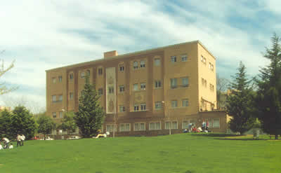

Fundació Busquets

After visiting Fundació Busquets our students have reached the following conclusions:

Poverty is a universal issue and it is increasingly worrying. It affects the whole world and our society. For this reason we should value life and know how lucky we are to have a family, a home, school, values. We have a pretty easy life.  
  
To collaborate actively with organizations like Busquets Foundation that helps people who need it.  
  
Maintain professional and social services offered by organizations like Fundació Busquets: housing for children without families, wardrobe, among others.  
  
We can help alleviate the situation of the poor by making donations, both individual and at institutional level (enterprises, schools, charitable groups…). The most needed products are food, clothing, soaps and cleaning products.  
  
Volunteering is very necessary, especially in the present world, in which people are often motivated by their economic interests. We should encourage voluntary actions in order to improve society and improve ourselves on a personal level.  
  
To raise the awareness in society, and specifically students, about different types of poverty, its distribution, risk groups and especially that poverty also exists in developed countries. It’s also a strategy to combat it.  
  
Promoting personal autonomy by professional training, education and also promoting personal and social abilities of people is important to eradicate it.   
  
It is necessary to console those who need it.  
  
The sponsorship of children is one way to help families who can afford their care for short periods.  
  
Help homeless people to find links to new people, help them recover from the internal injuries of life and get out of this vicious circle.  
  
To organize charitable activities such as plays, concerts, charity raffles, etc.  
  
To eradicate poverty in underdeveloped countries we should stop exploiting people and resources,  
  
It is very important the attitude of society, that takes a look supportive, respectful and dignified treatment to those suffering from this situation. Zoom victim-hood, guilt and contempt for these people.  
  
The collaboration of everyone is essential to eradicate poverty.

You can find more information in this link:

<http://www.hijascaridad.org/barcelona/c_hogares/Centros/centro2.htm>

**TURKEY**

**Organisation full legal name:**

**Ozel Gundogdu Ilkogretim Okulu**

**Type of organisation: Primary School**

**City: Konya**

Strategies in Poverty Reduction   
in Turkey

Despite the whole negative phenomena and all these effects of poverty, fighting against poverty is being lasted in our country by both institutional, organizational and govermental projects and plans and national integrity, sensitiveness of Turkish people to eachother :

* A social security system that keeps individuals from loss of income and insufficient income is available in the country. This system has been developing as a main security mechanism against poverty : Pension Fund (% 14.3) enclosing public servants, the Institution of Social Insurance (% 61.6) enclosing workers and Bağ-Kur (% 23.5), a government institution enclosing private sector officers consist of the main social security institutions in Turkey. Indviduals who work enclosed in any of these are secured against many social risks such as old age, sickness, disablement, work accident , etc.
* By the Law for the Encouragement of Social Assistance and Solidarity in 29th May, 1986 the Fund for the Encouragement of Social Assistance and Solidarity was comprised. The aim of the fund is to provide poor and needy people who are not included in any social security network with help, take measures assuring social justice and contribute into the development of income distribution.
* In order to providing relief for the effects of 2001 crisis, Reducing Social Risk Project was conducted by the financial and technical support of World Bank. And by this project which costed 500 million $ the application of In terms of fighting against poverty, there are some applications in education as well. In primary schools books are delivered without any charge to students. In addition, university students aare supported by state and some institutionaIn gender problems of poverty, some precautions are being taken: Micro-economy projects aiming at supporting women’s enterprise potantial are applied by various organizations. Within this framework, since 2002 Supporting Women Labour Organization has provided poor women with financial and technical support by the means of the micro-economical support enterprise so that these women can found their own business.
* Another important institution against poverty is Society for Social Service and Protection of Children. This institution gives nursing service to the old and deprived children and runs public nursery schools.